Supplementary Material for

Automatic Detection and Segmentation of Tooth Cracks Based on Improved Mask R-CNN

Yuanchang Huang, Yadong Tang, Juhao Wu, Jiayan He, and Wenlong Wang*

A. Implementation Details
A.1 Experiments on Learning Rate and Decay Strategy Selection
As shown in Fig. S1, to assess the impact of different learning rates and decay strategies on model performance, seven experiments were conducted with various learning rates and decay strategies. Specifically, some fixed learning rates (0.01, 0.001, 0.0001) was tested, as well as decay strategies that reduce the learning rate from 0.01 to 0.0001, including step decay, linear decay, exponential decay, and cosine annealing decay. Fig. S1(a) illustrates the curve of learning rate changes over epochs. For each experiment, the model’s loss values and average precision (AP^{seg}) values for segmentation were recorded, as shown in Fig. S1(b) and Fig. S1(c). The results indicate that the model using the cosine annealing decay strategy performed the best. Compared to other strategies, cosine annealing achieved the lowest and most stable final loss value, as well as the highest AP performance. This suggests that cosine annealing not only excels in reducing loss but also significantly improves the model’s detection accuracy. This learning rate and decay strategy has been used for training in subsequent experiments.
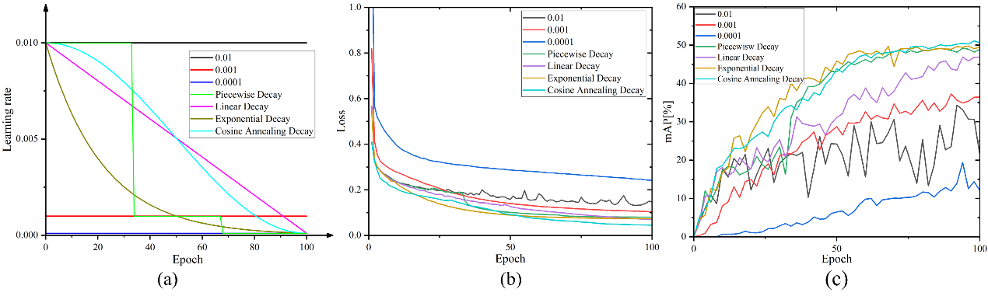
Fig. S1. Comparison of experimental curves for different learning rates and decay strategies. (a) Curve of learning rate with epoch. (b) Training loss curves for different learning rate strategies. (c) AP^{seg} curves for different learning rate strategies.
A.2 Experimental Results with Different Batch Sizes
To investigate the impact of batch size on model performance, experiments were conducted with batch sizes of 2, 4, and 8 under the cosine annealing decay strategy of learning rate. As shown in Table S1, the model performed slightly better in terms of AP^{bbox} and AP^{seg} with a batch size of 4. However, with a batch size of 8, although there was a slight decrease in AP^{bbox} and AP^{seg}, the model achieved improved mIoU^{seg} and mF1^{seg}, along with a significantly reduced training time. Therefore, a batch size of 8 was selected for the subsequent experiments, balancing both performance and training efficiency.
TABLE S1
COMPARISON OF MODEL PERFORMANCE ACROSS DIFFERENT BATCH SIZES
Learning rate | Batch-size | AP^{bbox} | AP^{seg} | mIoU^{seg} | mF1^{seg} | Train time
Cosine Annealing Decay | 2 | 79.60 | 47.65 | 88.68 | 88.48 | 13.80h
 | 4 | 79.83 | 47.51 | 88.21 | 88.04 | 10.21h
 | 8 | 79.51 | 47.80 | 88.16 | 88.64 | 6.67h

B. Backbone Attention Analysis via Eigen-CAM Visualization
To gain deeper insights into the performance of different backbones in tooth crack detection and segmentation, we utilized Eigen-CAM to generate heatmaps, allowing a visual comparison of how effectively each backbone focuses on crack features. These heatmaps illustrate the attention distribution of each network when processing sample images, aiding in visualizing and interpreting their decision-making processes.
Fig. S2. Visualization comparison of different backbones using EigenCAM. (a) original image, (b) ground-truth, (c) ConvNeXt-tiny, (d) PVT-v2b1, (e) Swin-transformer-tiny, (f) ResNet-50, (g) ResNeXt-50(32×4d).

As shown in Fig. S2, the heatmaps use a color gradient from blue to red to indicate attention levels, with blue representing low attention areas and red representing high attention areas. The results demonstrate that the model employing ResNeXt-50(32×4d) as the backbone yields slightly higher performance compared to that using ResNet-50, whereas the remaining three backbones exhibit markedly inferior results in both bounding box detection and segmentation tasks, with Swin-Transformer-Tiny performing the worst. The superior performance of ResNeXt-50 and ResNet-50 can be attributed to their convolutional architectures, which possess strong inductive biases for capturing local spatial features. Such characteristics are particularly advantageous for detecting fine-grained and spatially localized structures, such as subtle cracks in teeth. In contrast, the other three backbones, which rely primarily on global self-attention mechanisms and non-overlapping patch tokenization, may be less capable of preserving and utilizing fine-grained local features, making them less effective at identifying the narrow and low-contrast patterns characteristic of tooth cracks. Consequently, based on both the experimental results and architectural advantages, ResNeXt-50(32×4d) emerges as the most suitable backbone for the proposed framework.

C. Radar Chart Visualization of Ablation Study Results
To provide an intuitive explanation for the ablation results in Table 4 of the main text, we plotted radar charts summarizing the effect of each module across six evaluation metrics: AP^{bbox}, APbbox 50, APbbox 75, and AP^{seg}, APseg 50, APseg 75. All values are compared against the baseline Mask R-CNN.
Fig. S3(a) illustrates the relative performance changes when introducing each module—ResNeXt, CFEM, and the encoder-decoder structure incorporating dynamic snake convolutions—into the original Mask R-CNN independently. Among them, ResNeXt yields slight improvements, particularly in APbbox 75 and APseg 75, reflecting a marginal enhancement in the model’s ability to localize and segment fine structural details. CFEM shows moderate gains in APseg 50 and APbbox 75, indicating its utility in refining mid-level feature representation and improving orientation-aware crack detection. While the numerical improvements introduced by ResNeXt and CFEM are limited, both components are designed with efficiency in mind and do not introduce noticeable increases in network complexity or parameter count. This makes them practical additions for maintaining model efficiency while offering targeted performance benefits. The encoder-decoder structure incorporating dynamic snake convolutions, in contrast, leads to more substantial improvements across the segmentation metrics, particularly AP^{seg} and APseg 75, suggesting its effectiveness in producing coherent and detailed mask predictions.
Fig. S3(b) focuses on the cumulative effect of sequentially integrating these modules into the baseline architecture. The transition from the original Mask R-CNN to the ResNeXt-based variant results in modest changes across most metrics. Adding CFEM leads to further performance refinement, with visible gains in both bounding box and mask accuracy. The full integration of ResNeXt, CFEM, and the encoder-decoder structure with dynamic snake convolutions yields the most balanced performance across all six metrics, demonstrating the benefit of combining structural and contextual enhancements in a complementary fashion.
In summary, while ResNeXt and CFEM contribute small but measurable improvements without increasing model complexity, the encoder-decoder structure with dynamic snake convolutions serves as the primary driver of segmentation quality. The radar charts thus provide a comprehensive depiction of both individual module effects and their combined impact on overall detection and segmentation performance.
Fig. S3. Radar charts illustrating the individual and cumulative performance improvements of ResNeXt, CFEM, and the encoder-decoder structure incorporating dynamic snake convolutions over the baseline Mask R-CNN. (a) Individual addition of each module. (b) Progressive integration of all modules.

B. F1-Score Analysis of Other Models on Tooth Crack Segmentation
The box plots presented in Fig. S2 provide a comparative analysis of the F1-score achieved by five popular instance segmentation models—YOLOv11, BlendMask, CondInst, Mask R-CNN, and our proposed model—on two distinct datasets. Fig. S2(a) corresponds to Dataset A, and Fig. S2(b) illustrates the performance on Dataset B.
In Fig. S2(a), our model achieves the highest median F1-score and demonstrates a tighter interquartile range compared to other models, indicating both superior performance and consistency in detecting localized tooth cracks. Notably, YOLOv11 shows competitive median performance but exhibits a wider range of variability. BlendMask, CondInst, and Mask R-CNN, while showing reasonable performance, lag behind our model in terms of median F1-score and consistency.
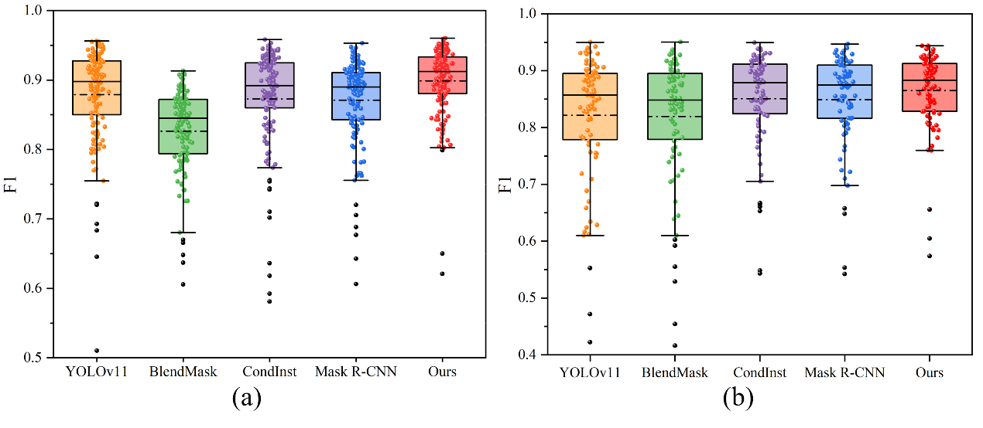
Fig. S2. F1-scores of other model on different segmentation target test sets. (a) Performance results on Dataset A. (b) Performance results on Dataset B.

Fig. S2(b) highlights the robustness of our model when applied to the more complex task of detecting cracks of varying orientations in Dataset B. Again, our model achieves the highest median F1-score and displays the narrowest interquartile range, reinforcing its capability to generalize across diverse crack orientations. The other models, particularly YOLOv11 and BlendMask, show greater variability in their F1-scores, with CondInst and Mask R-CNN displaying relatively lower median scores. The overall trend suggests that the complexity of Dataset B poses greater challenges for the baseline models compared to our proposed method.
These results collectively demonstrate the effectiveness and reliability of our model in both localized and multi-orientation crack detection tasks, outperforming competing other models across two challenging datasets.

C. Robustness of Improved Mask R-CNN for Tooth Crack Segmentation
Table S2 compares the performance of the original Mask R-CNN and our improved Mask R-CNN model under various image transformations, including brightness adjustment, Gaussian blur, and Gaussian noise. The results show that our improved model consistently outperforms the original in all metrics, indicating better detection and segmentation of tooth cracks.
For all types of image transformations, including changes in brightness, blurring, and noise, the improved model demonstrates enhanced robustness. It performs better in scenarios with altered lighting conditions, blurred images, and noise interference, suggesting that the improvements in the model architecture contribute to more accurate and reliable crack detection in challenging environments.
Overall, these findings highlight the superior performance and robustness of our improved model, making it more suitable for real-world applications where image quality may be compromised due to various factors like lighting, blur, and noise.

TABLE S2
ROBUSTNESS OF MASK R-CNN FOR TOOTH CRACK SEGMENTATION UNDER VARIOUS TRANSFORMATIONS
Image transformation | Method | mPrecision | mRecall | mIoU | mF1 | AP
Original image | Mask R-CNN | 79.33 | 87.97 | 88.64 | 88.16 | 42.37
 | Ours | 81.99 | 89.28 | 90.89 | 89.89 | 47.80
 |  | +2.66 | +1.31 | +2.25 | +1.73 | +5.43
Brightness  (+0.25) | Mask R-CNN | 77.23 | 86.80 | 87.15 | 86.77 | 37.31
 | Ours | 80.91 | 88.69 | 89.94 | 89.22 | 41.56
 |  | +3.68 | +1.89 | +2.79 | +2.45 | +4.25
Brightness  (-0.25) | Mask R-CNN | 74.77 | 86.68 | 84.14 | 85.09 | 37.73
 | Ours | 78.90 | 88.17 | 87.98 | 87.94 | 42.57
 |  | +4.13 | +1.49 | +3.84 | +2.85 | +4.84
Gaussian blur  (kernel-size=5×5) | Mask R-CNN | 69.85 | 81.19 | 83.33 | 81.43 | 30.70
 | Ours | 75.82 | 83.89 | 88.61 | 85.91 | 38.93
 |  | +5.97 | +2.70 | +5.28 | +4.48 | +8.23
Gaussian noise  (=0.05) | Mask R-CNN | 47.55 | 81.21 | 51.18 | 61.95 | 6.88
 | Ours | 66.27 | 85.69 | 74.23 | 78.50 | 25.79
 |  | +18.72 | +4.48 | +23.05 | +16.55 | +18.91

